Department of Planning and Community Development
1 JFK Memorial Drive
Braintree, Massachusetts 02184
Peter Matchak, Director
Phone: 781-794-8234

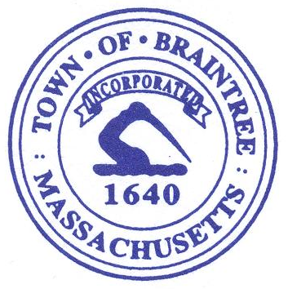
Mayor
Erin V. Joyce

Historical Commission
Kate Nedelman Herbst, Chair
Thomas Devin, Member
Ronald Frazier, Member
Santina Giannino, Member
Carl R. Johnson III, Member
Vacant, Member

Historical Commission - Meeting Agenda
Monday, February 2, 2026
6:00PM
Fletcher Chambers

- Call the Meeting to Order

- Demolition Delay Discussion

- Approval of December 15, 2025 Minutes.

- Revote on the Approval of Meeting Minutes: October 16, 2023; January 8, 2024; February 5, 2024; March 4, 2024; April 1, 2024; May 6, 2024; December 2, 2024; July 29, 2025.

- Revote on the Approval of the 2026 Meeting Schedule

- Adjournment

Reasonable accommodations will be provided for persons with disabilities.
To request accommodations, please call Braintree’s ADA Coordinator at 781-794-8327 at least seven business days in advance. Arrangements will be provided at no cost.

