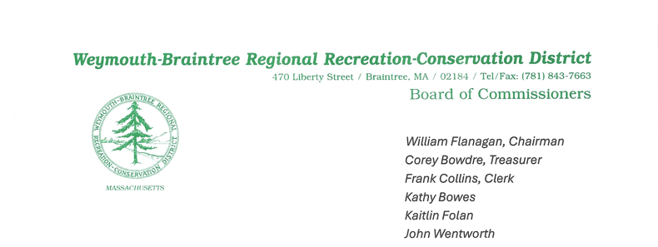
Pond Meadow Park Commission Meeting Minutes
Date: March 19, 2025
Time: 7:00 PM

1. Call to Order & Roll Call
The meeting was called to order at 7:03 PM.
Present:
Commissioners: Bowes, Bowdre, Collins, Folan, Wentworth
Supervisory Ranger: Keefe
Guest: Joseph Kowalski, Forester
Absent: Commissioner Flanagan

2. Guest Speaker – Joe Kowalski
- Mr. Kowalski reached out to Massachusetts weed specialist Randy Prostak to discuss his services, including a conference call with Brion and Joe.
- Estimated cost for a prescriptive report is $600 per day, with additional travel costs of $180 + tolls. These costs will be covered under the grant for the meadow.
- Mr. Kowalski informed the group about an Urban and Community Forestry Grant available, offering 50% to 75% reimbursement for tree planting in the park.
- Mr. Kowalski will send Commissioner Folan the grant information for her to draft

3. Approval of February 19, 2025 Regular Meeting Minutes
- Motion: Commissioner Bowes motioned to approve the February 19 meeting minutes. Commissioner Bowdre seconded the motion. Motion passed unanimously.

4. Treasurer’s Report
- Checks: Commissioner Bowdre reported that the checks that were ordered online have been received.

5. Supervisors’ Report
- #4: A $4,500 grant has been applied for from the state to assist with the emergency action plan, which includes mapping of the landing area. If the grant is not approved, the towns will need to bear the cost.
- #6: Ranger Nikitchuk is enrolled in the UMASS Pollinator Program and is halfway through.
- #7: Braintree Electric Light removed trees around the building free of charge. Five more trees are scheduled for removal in the next week or two.
- #8: A harrow for the tractor has been ordered and is expected to arrive around April 8th.
- #11: A dam inspection was performed, revealing issues with grading and the ladder at the dam. The estimate to replace the ladder and galvanized steel grating is between $25,000 and $35,000. The dam must be inspected every two years by an outside engineering firm, and an emergency action plan (EPA) must be updated every five years.
- #12: An electronic copy of the operations & maintenance manual was requested. Braintree Engineering provided the electronic copy free of charge.
- #13 & 14: Work has been done to expand the big and old meadows, including mowing invasive species, removing invasive trees, and spreading wood chips.
- #15: Soil testing showed a pH of 6.5, with potassium surplus, sufficient nitrogen, and sufficient phosphorus. These results are favorable for pollinator wildflower seeds, which thrive in neutral or slightly acidic soil.
- #18: It was reported that the Legere case was settled.
- Commissioner Bowes inquired if any abutters had reached out regarding the meadow work and invasive species removal. Ranger Keefe responded that no calls have been received.

6. Chairman’s Report (covered by Commissioner Collins)
- Due to the lack of responses regarding the recorder position, the monthly payment will be $300.
- Before the invasive species removal begins in the meadow, the board should consider having the land surveyed. Commissioner Collins suggested Jim McGrath, a town surveyor, who provides professional services at a reasonable price.
- Commissioner Folan made a motion to approve a survey not to exceed $1,000. Commissioner Bowdre seconded the motion, and it was approved unanimously.
- Regarding invasive removal, Commissioner Wentworth made a motion to engage George Thibeault for invasive species removal, not to exceed $7,000. Commissioner Bowes seconded the motion, and it was approved unanimously.

7. Friends of Pond Meadow Park Report (Presented by Commissioner Collins)
- The Friends of Pond Meadow Park currently have $35,031.68.
- The Friends group will fund the weed specialist (approx. $800) and the harrow (approx. $5,000).
- Commissioner Collins is looking for another conex box for the park.
- Recent donations were discussed, including a $500 donation following the Braintree Rotary Club presentation.
- Commissioner Collins requested Ranger Keefe to let him know when he learns which stone can be used for the dirt road. The Friends will cover the cost of the stone.
- Ranger Keefe inquired whether the board would be open to using asphalt instead of stone. Discussion ensued, and Ranger Keefe will follow up to determine if there are any restrictions on using asphalt near water.

8. Old Business:
- The idea of creating a path through the pollinator meadow was discussed.
- Commissioner Bowes inquired about bids for work on the office. Ranger Keefe reported that the amounts were submitted as part of the budget, and no updates have been received. Bids need to be obtained by July 1st.

9. New Business
- Ranger Keefe reported that the chipper has malfunctioned and is no longer operational. Discussion followed regarding next steps.
10. Commissioners and Ranger Comments
- Ranger Keefe thanked the Friends group for their contributions to the pollinator meadow.
10. Motion to Adjourn
A motion to adjourn was made by Commissioner Bowes and seconded by Commissioner Wentworth. The meeting was adjourned at 8:21 PM.

Minutes submitted by: Kaitlin Folan
Date: March 24, 2025

