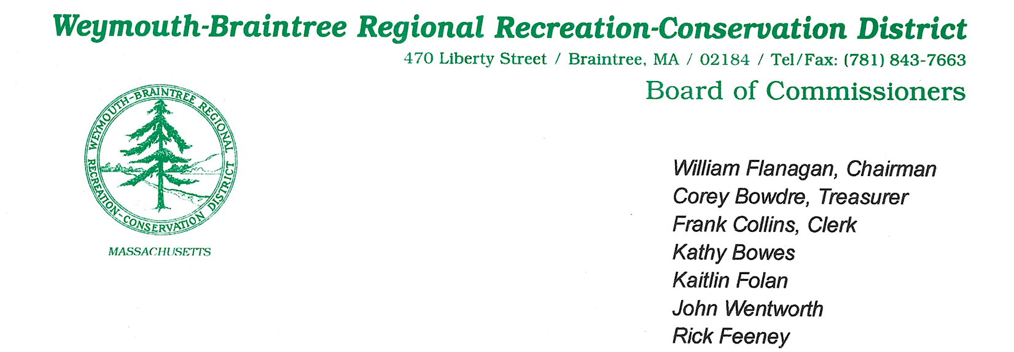
Meeting Minutes
Date: September 17, 2025
Time: 7:00 PM
Location: 470 Liberty Street, Braintree, MA 02184
Called to Order (7:01pm) By: Commissioner Flanagan

Meeting Proceedings
7:02 PM
- The Pledge of Allegiance was recited.

Roll Call (7:02pm)

Commissioners

Present: William Flanagan (Chair), Frank Collins (Clerk), Kathy Bowes, John Wentworth, Rick Feeney, Kaitlin Folan

Absent: Corey Bowdre (Treasurer)

Staff
Present: Supervisor Brion Keefe
Absent: Ranger Mike Nikiciuk

Guests Present: None

Approval of Previous Months Minutes

- 7:03 PM: Chair called for approval of previous meeting minutes.

Motion: Motion to accept August 20th minutes by Commissioner Wentworth
Second: Commissioner Bowes
Vote: Unanimous Approval

Treasurer’s Report (7:03 PM)

- Given by Supervisor Keefe
- Checking balance $43,320.80 and Savings Balance: $235,985.65
- Highlighted the Forest Fund reimbursement from the State $14776.66 total balance now $18,366.94
- Confirmed receipt of both payments from the Towns for the initial half of the year. It was more than the half of the appropriation to have more up front for early fiscal year costs.
- Still waiting on new computer with new quick books before establishing up to date annual ledger.

Chairman’s Report (7:08 PM)

- Chair discussed subcommittee to review bylaws and was looking for volunteers. Commissioner Flanagan, Commissioner Wentworth and Commissioner Feeney volunteered, along with Supervisor Keefe. Will electronically send out before next business meeting.
- Pollinator meadow was a great start. Mugwort is a problem that is holding us back a bit. Chair met with staff and went into the field to investigate mugwort reproductive process. Mugwort was cut to try and stave off any further growth. Further assessment will take place. Spoke about the State grant and that it will not be the amount initially hoped for in FY26. Scope of work for the grant will need to be cut back.
- Emphasis on Pond Treatment. Wanted to bring to light the “dissolved oxygen” reports. It is significantly better. Treating in the Fall for lily pads and in the spring for other growth (Millfoil). Looking forward to results come next spring.
  - Commissioner Feeney inquired about the treatment process and Supervisor Keefe gave an detailed explanation with how the contractor does it.
- Brought up electric Bicycles and how it is rampant everywhere with speed and irresponsible operation. In speaking with several public safety officers, the thought is that the State will be coming out with further guidance regarding E-Bikes.

Supervisor’s Report (7:23 PM) – Given by Supervisor Keefe

Highlights:
- #4 Grant Reimbursement – Received $14,766.66 from the State back to the forest fund. A 75 percent reimbursement for the total cost of the work.
- #5 Water & Wetland – Wednesday, September 3, 2025. Second round of herbicide treatment was coordinated and carried out.
- #6 GZA Dam Received the GZA Dam Inspection form and will be submitted to the Office of Dam Safety for Approval. Checks will be written to GZA next week.
- #7 Pressure washer – RB800 Pressure washer was purchased from Stewarts. This will be used to maintain equipment as part of the maintenance schedule. Purchase was a Capital expense line item.
- #11 Mugwort – Problems continue, and it has never been as thick as it is now. In the preparation of the meadow for pollinator-friendly planting, the process of turning over and aerating the meadow created a perfect environment for the Mugwort to thrive. To prevent Mugwort seeding, much of the meadow was mowed, pushing the tractor to its limits.
  - Randall Prostak (invasive specialist) from UMass Amherst was mentioned by Commissioner Folan to deal with the Mugwort.
  - Looking to have him evaluate as much as possible for $1000.00
  - Discussion about timeline to bring him in on using our funds or waiting for State Grant.
  - Chair Flanagan motioned and seconded by Commissioner Folan NTE (not to exceed) $1500.00 to schedule him to evaluate and make recommendations of the Park Meadows this Fall.

- #12 CPC Funds from Weymouth - $163,125 from the unreserved fund for Brookside Road Fish Ladder Project.
  - Braintree also voted and approved $175,650.00. An increase was built in so that the commission did not have to come back with any change orders.
  - Both Towns inquired about the Federal Funds. Army Corps of Engineers says everything looks good and we will be waiting on their final approvals
  - Commissioner Bowes inquired about start date. Looking at fall 2026 or spring 2027.
- #13 Insurance – Documents have been signed to renew with Oliveri insurance
- #14 Grant Application – Grant app will have to be changed due to the potential funds being less than initially expected.
- #16 Education – Hoisting education and license renewal online through Commissioner Feeney

Commissioner Bowes inquired about #15 Health Insurance Checks.
  - Supervisor Keefe explained that there are changes coming and he is waiting on information from Weymouth Human Resources. Weymouth HR has reached out to former Supervisor Cleaves and has yet to receive confirmation from him that he has received the info. Once they have that info they can process the changes.
  - Spoke to Robert Conlon to try and investigate the amounts. He will be looking to Weymouth Retirement Board for help.

Commissioner Collins commented about Mugwort and his research. Complimented the staff on the hard work.

Commissioner Bowes inquired about #19. Liberty Siding. Supervisor Keefe clarified that it was for the door replacement project. Check was disbursed for $11,450.00

Friends of Pond Meadow Park Report (7:50 PM) – Presented by Commissioner Collins

- Checking account balance: $25,272.89
- Potentially 3 Signs will be going in to have QR Code displayed for donations.
- Looking to have some invasive removal days and further fundraising.
- Recorder suggested using the on-line donation site SQUARE. Commissioner Collins will look into it.

Old Business (7:57 PM)

- Smelt Brook: CPC Money has been approved
- FY26 Grant Needs: Grant needs to be reworked as stated above due to financial limitations.
- Abutters Letter: Draft letter from John Oliveri to be given to the abutters to if they are to remove any trees directly above the property lines. Letter has detailed information and process for abutters. Corrections were made and given to Supervisor Keefe.
  - Commissioner Bowes inquired about the Liberty Street property. It is on the owner’s property, and they would bear all costs. Supervisor Keefe mentioned being a good neighbor and being accommodating for access.
- E-Bikes in park: Constant issues for Park Staff. Supervisor Keefe mentioned several instances where they refuse to stop and comply with basic requests. Braintree Police have been involved.

New Business (8:01 PM)

- Water and Wetland inspection:
  - Mentioned earlier (Treatment occurred September 3rd.
  - Effects will take place after a time. Usually doesn’t happen right away.
- Status of new ranger recruitment
  - Job Posting is completed and ready to go. Need to decide what platform to use.
  - Spoke about what kind of individual needed, position will require a bachelor’s degree in forestry management, Environmental Science or other related specialty. Not just a laborer. Need to be someone who can be able to do it all.
  - Inquired about career centers at the Universities nearby.
  - Chair inquired about subcommittee for hiring new ranger. Commissioner Bowes and Folan volunteered and will sit on it with Supervisor Keefe and Ranger Nikiciuk.
- Supervisor Keefe suggested using the remaining 50lbs of meadow seed at the highway meadow section near the Weymouth side. Fall is the best time to plant that. Supervisor Keefe believes this would beautify the area for little effort. No invasives are in that area. The commission agreed and this will move forward.
- Supervisor Request: Demolition jack hammer for breaking up concrete. It is corded and will require a generator to be used. Request not to exceed $1100.00 from the “New Equipment Fund”
  - Motion made by Commissioner Wentworth not to exceed $1100.00
  - Second by Collins
    - Discussion led to Commissioner Feeney researching options to obtain a potential donation
      - Vote: Unanimous
- Supervisor Request: Metal cutoff saw. $249.00 plus extras. Not to exceed $300.00 from the “New Equipment Fund”
  - Motion made by Commissioner Bowes not to exceed $300.00
  - Second by Commissioner Collins
    - Vote Unanimous

Commissioner Comments (8:30 PM)

- None

Adjournment (8:30pm)

Motion: Motion to adjourn Commissioner Bowes
Second: Commissioner Wentworth
Vote: Unanimous Approval
Respectfully submitted

Ryan C. MacLeod
Recorder

