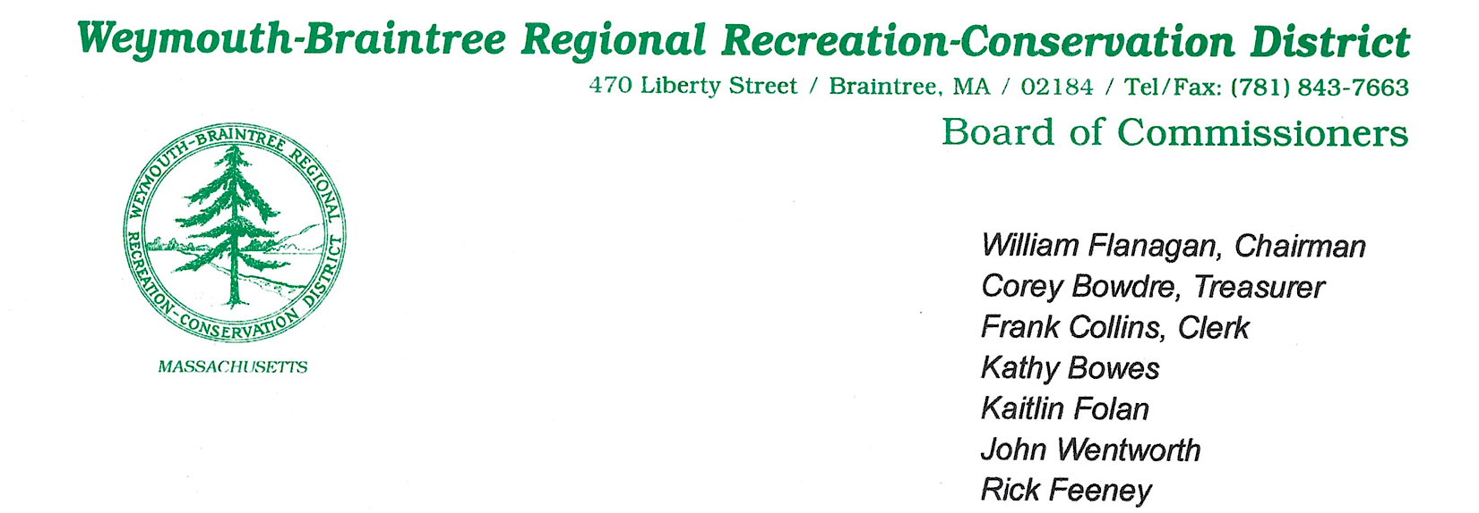
Meeting Minutes
Date: October 15, 2025
Time: 7:00 PM
Location: 470 Liberty Street, Braintree, MA 02184
Called to Order (7:00pm) By: Commissioner Flanagan

Meeting Proceedings
- The Pledge of Allegiance was recited.

Roll Call

Commissioners

Present: William Flanagan (Chair), Frank Collins (Clerk), Corey Bowdre (Treasurer), Kathy Bowes, John Wentworth, Rick Feeney, Kaitlin Folan

Absent:

Staff
Present: Supervisor Brion Keefe
Absent: Ranger Mike Nikiciuk

Guests Present: Mark Salzillo

Guest Speakers

Mark Salzillo presented his business plan for Eco Preschool, proposing the construction of a yurt on the park grounds, a fenced in area for play, and a school year starting in September 2026 among other items. Questions posed by Commissioners and Ranger Keefe. Discussion ensued. Commissioner Flanagan made a motion, after careful consideration, to deny the proposal set forth by Mark Salzillo for the Eco Preschool to be established on the grounds of Pond Meadow Park. Commissioner Bowes seconded.

Motion: Motion to deny “Eco Preschool” proposal by Commissioner Flanagan
Second: Commissioner Bowes
Vote: Unanimous Approval

Approval of Previous Months Minutes

- Chair called for approval of previous meeting minutes.
- Commissioner Collins asked for an edit to the header to add Commissioner Feeney.

Motion: Motion to accept September 17th minutes by Commissioner Bowes as amended
Second: Commissioner Wentworth
Vote: Unanimous Approval

Treasurer’s Report

- Given by Commissioner Bowdre
- Commissioner Bowdre presented the financial position of the park, including amounts in the pond restoration fund, forest fund, and new equipment fund. Funds for the 2025/2026 fiscal year were received from both towns. Purchases since the last meeting included a standing mower, pressure washer, and down payment for the building doors.

Chairman’s Report

- Reached out to Edward DeLuca CPA who met with Commissioner Flanagan and Supervisor Keefe to serve as the Parks consulting accountant, setting up QuickBooks, providing incremental oversight of Park bookkeeping and providing ad hoc consulting services to the Park Ranger staff moving forward.
- Grant for FY26 was approved by Community Woodland for $19,195.47 (net of the amount PMP is required to contribute)
- Recognized ranger efforts during the storm over the long weekend (over 6 inches of rain), with no flood issues. This included but was not limited to managing the Pond level prior to as well as during the storm, maintaining the spill-way adjacent to Brookside Ave flawlessly.

Supervisor’s Report – Given by Supervisor Keefe

Highlights:
- #2: Storm dropped over 6 inches of rain over the past long weekend. Pond level was dropped 15 inches, no flooding issues.
- #5: Water and wetland completed the third round of weed treatment on 10/2/25
- #6: Posted position for third park ranger. Received over 140 applicants. Ranger Keefe provided the subcommittee several resumes for review. Posting has been paused until the subcommittee reviews the current pool of resumes received.
- #8: Randy Prostak will be visiting the park on Monday, October 20th to assess the meadow for invasive weed species, specifically mug wort.
- #10: Selected to receive a FY26 Community Woodland Grant for $19,195.47 (state portion, which is net of the park’s amount). Gross grant is $25,000.
- #12: Received a new computer and VIP computer is helping to transfer programs and documents over to the new computer. Commissioner Bowes asked what we use for security. Ranger Keefe replied that MacAfee is being used currently.
- #13: The Community Preservation Act Grant Agreement was approved by both towns for Brookside fish ladder project in the amount of $163,125 to be taken from the unreserved fund. Town of Braintree gave $175, 650 and Weymouth contributed $163,125. Braintree’s amount included potential overrun amounts.
- #14: The pavilion has been utilized for birthday parties where confetti and other items are being left (littering). The commission discussed placing signage at the picnic table area and pavilion that prohibits confetti or other environmentally harmful materials as well as “carry-in, carry-out” obligations.
- #19: Assisted Braintree police to apprehend a public flasher in the park
- #21: Contacted Amanda Lewis, Director of Mass Trails DCR to explore potential grants or available funding for the bridge replacements near the highway.
- Commissioner Bowes inquired about whether it is worth reaching out to the town grant writers. Discussion ensued.

Friends of Pond Meadow Park Report – Presented by Commissioner Collins

- Current account balance: $25,272.89 in the checking, savings has $4.
- Commissioner Folan is the new treasurer.
- The friends will be working on the new QR codes and setting up a PayPal account for donations.

Committee Reports

Ranger Three Recruitment Committee:
- Commissioner Flanagan, Bowes and Folan discussed scheduling a time to go through the resumes Ranger Keefe identified
Bylaw Sub-Committee
- Committee will pick back up in a few weeks

Old Business

- Smelt Brook Ladder update noted above
- Weed treatment specialist is scheduled for October 20, 2025, as noted above
- Abutters letter is in final drafting stage
- Pond treatment has been performed with tremendous results, final bill pending

New Business

- Edward DeLuca met with Commissioner Flanagan and Ranger Keefe as noted above
- Rules and signage for pavilion and picnic area noted above. Commissioner Flanagan to work with Supervisor Keefe on the language for the signage. Commissioner Bowes suggested also noting consequences of not following the rules. Commissioner Wentworth suggested including the sign in several different languages.
- Inquiries of use of the park nature center for events. Ranger Keefe informed the commission that we historically have only allow the scouts to use the room, who provide certificate of insurance. The scouts support the park with various projects. No other events are allowed in the facilities.

Commissioner Comments

- Commissioners extended their thanks to the rangers

Adjournment (9:19pm)

Motion: Motion to adjourn Commissioner Bowes
Second: Commissioner Wentworth
Vote: Unanimous Approval
Respectfully submitted

Ryan C. MacLeod
Recorder

