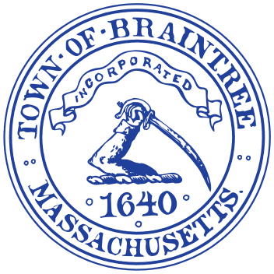
Office of the Mayor
One JFK Memorial Drive
Braintree, Massachusetts 02184

Erin V. Joyce

Mayor Joyce Announces Police Chief Cohoon’s Resignation and
Acceptance of Appointment as Chief of the Newton Police Department

Earlier today, Braintree Mayor Erin Joyce accepted the notice of resignation from Chief Timothy Cohoon of the Braintree Police Department. In tendering his notice, Chief Cohoon advised Mayor Joyce that he has been appointed to serve as the Chief of Police of the Newton Police Department. Under the terms of his employment contract with the Town, Chief Cohoon will continue to serve as Chief of the Braintree Police Department for another 30 days. His last day of service with Braintree will be on Wednesday, February 11, 2026.

As Mayor Joyce notes, “On behalf of the Town, its residents, and its employees, I thank Chief Cohoon for his decades of service in the Braintree Police Department. His wide-ranging background in law enforcement, the accolades he earned along the way, and his experience as a senior executive, will serve him well when he joins Mayor Laredo’s team in the City of Newton. I wish Chief Cohoon great success in his new position.

“Additionally, I will periodically update the public, to the fullest extent possible, on the Town’s efforts to engage a successor to serve as Chief of the Braintree Police Department. I am committed to transparency throughout this process.”

Chief Cohoon added, “I thank Mayor Joyce for her kindness and well wishes as I wind down my time in Braintree. I likewise thank the men and women of the Braintree Police Department for their service and professionalism. Whether sworn or civilian, the Department’s staff are always dedicated to the safety and security of the Town and its residents. I have been honored to serve as their Chief and I look forward to seeing their continued progress in the future. Braintree will always be close to my heart.”

Mayor Joyce will make future public announcements as the engagement of a successor moves forward. In the meantime, should you have any questions, you may contact the Mayor at 781-794-8100 or mayorsoffice@braintreema.gov.

