CALL TO ARTISTS
Public Art in Braintree, Massachusetts
Submission Deadline: March 31, 2026
Description
The Town of Braintree seeks proposals from artists interested in creating public murals on the road in front of the Town Hall entrance and on the ADA ramp leading to Town Hall to highlight those key areas of the Town Hall complex. Artists and designers with experience in creating public murals are encouraged to submit proposals. The Town is particularly interested in murals that emphasize Braintree’s rich history and contribute to the community’s growing public art landscape.
Braintree is committed to expanding its public art scene, and creating a more vibrant, welcoming, and visually engaging environment for residents, visitors, and businesses.
Eligibility
Residents of Braintree, Massachusetts, are strongly encouraged to submit proposals. The Town does not discriminate based on race, color, religion, gender, gender expression, age, national origin, disability, marital status, sexual orientation, or military status in any of its activities or operations. Grants to artist(s) total $9,000, with $5,000 funded by the Massachusetts Cultural Council and a $4,000 contribution from the Town of Braintree, for a combined total of $9,000. Materials purchased or provided by the Town are included within this amount.
Location
Proposed mural location: roadway surface in front of Town Hall entrance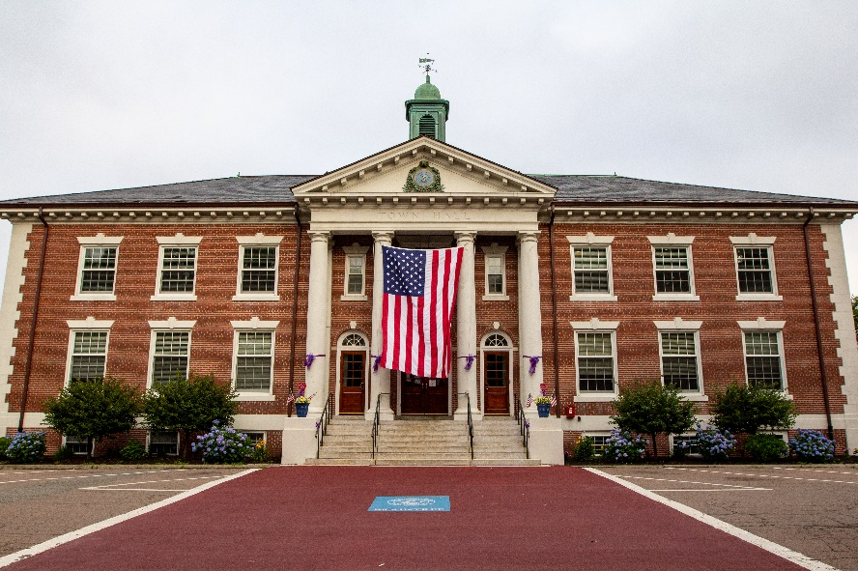

ADA ramp:
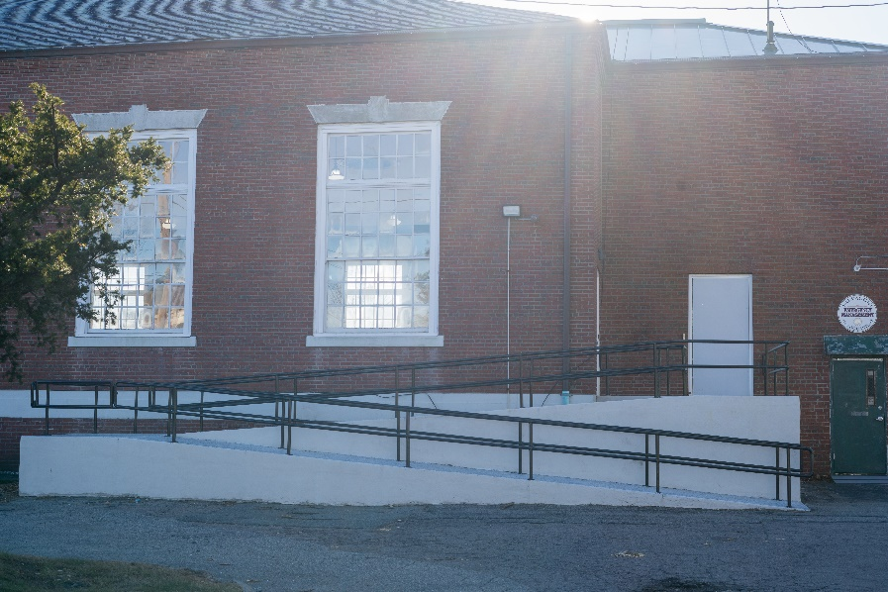
Proposal Requirements
Proposals must include the following items:
- Resume/Bio with contact information and website (if applicable)
- Four examples (jpeg, png, or pdf) of previous mural work
- Site-Specific Project Proposal (one per site) including:
  - Title
  - Location (Town Hall entrance, as well as the ADA ramp and wall leading to Town Hall)
  - Description of the project
  - Total budget not to exceed $9,000 for both sites, including artist time, materials, transportation, engagement, insurance, and contingency.
  - Three examples of the proposed mural
  - Dimensions
  - Timeline
Proposals will NOT be considered if they involve:
- Breach of intellectual property rights
- Trademarks, brand names, logos, or copyrighted images
- Profanity or offensive imagery
Installation & Site Coordination
This project involves the creation of painted murals on existing public surfaces. The Town of Braintree will coordinate site access and surface preparation as needed. At least one Public Works employee will be on-site during installation. Selected artist(s) will be responsible for executing the mural artwork in accordance with Town guidelines and approved designs, and for providing material specifications, surface preparation needs, and maintenance recommendations. All work will be completed in coordination with the Town.
How to Submit Your Proposal
- Email proposals to: adeng@braintreema.gov OR
- Deliver proposals in sealed envelopes to:
Town of Braintree, Mayor’s Office
1 JFK Memorial Drive, Braintree, MA 02184
- Clearly indicate the title of the proposal and the artist’s name and address on the envelope.
- Late proposals will not be accepted.
Schedule
- Call to Artists Posted: February, 2026
- Proposal Due Date: March 31, 2026
- Info Session (optional): To be announced, if scheduled
Disclosure Statement
The Town of Braintree is not liable for any costs incurred in submitting proposals. The Town reserves the right to reject any or all proposals, make multiple awards, and determine the best use of grant funds.
Evaluation Criteria
Proposals will be evaluated on:
- Experience & Competence: Preference for artists with prior mural experience.
- Idea/Design Quality: Alignment with Braintree’s history and public art vision.
- Price: Proposals must not exceed $9,000 (inclusive of all costs).
Results
Selected artist(s) will enter into a grant agreement with the Town of Braintree. The Mayor of the Town of Braintree will choose the winning proposal(s) in the Mayor’s sole discretion. All work must be completed by June 30, 2026.

